**Task 5: Plugins in Jenkins**

**Plugins in Jenkins** are add-ons or extensions that enhance the core functionality of Jenkins by providing additional features. They allow Jenkins to integrate with various tools, platforms, and technologies used in software development, deployment, and automation.

In this document, I have provided a detailed overview of the **Available Plugins** and **External Integrations.**

* In Jenkins dashboard we have a distinctive section for Plugins
* Under Plugins Manager we have,
* Updates
* Available Plugins
* Installed Plugins
* Advanced Settings

**Updates:**

It ensures that installed plugins are up-to-date, secure, and compatible with the current version of Jenkins.

**Available Plugins:**

This section list out the plugins which are available to install and they are provided by Jenkins Plugin manager.

1. **Successfully logged into Jenkins**

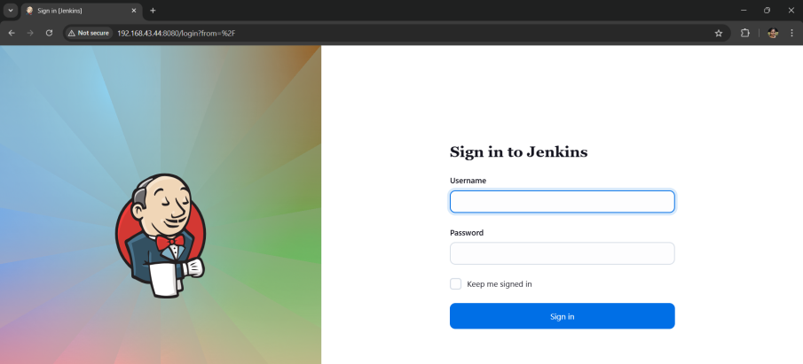

1. **Go to Dashboard->Manage Jenkins->Plugins->Available Plugins-> Select the “Safe Restart” Plugin->Click on Install**

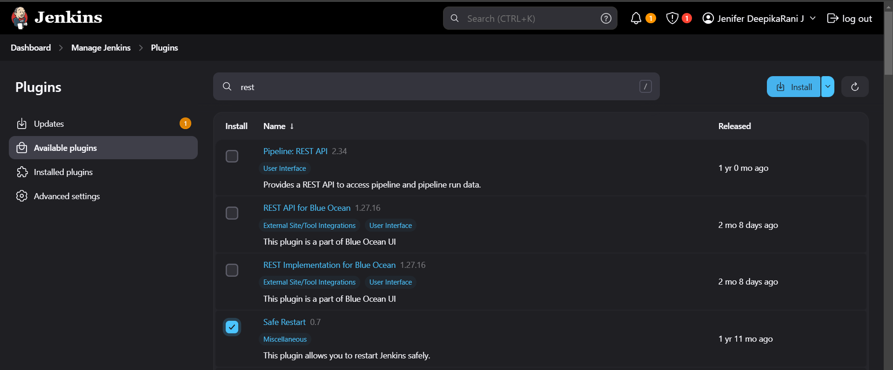

* The **Safe Restart Plugin** in Jenkins is designed to allow administrators to restart the Jenkins server safely, ensuring that any running builds are not disrupted or terminated unexpectedly.

1. **After installing any Plugin we should restart the Jenkins server. So that, I have Restart the Server.**



1. **The Installed Plugin will be located in the Jenkins Dashboard Automatically**

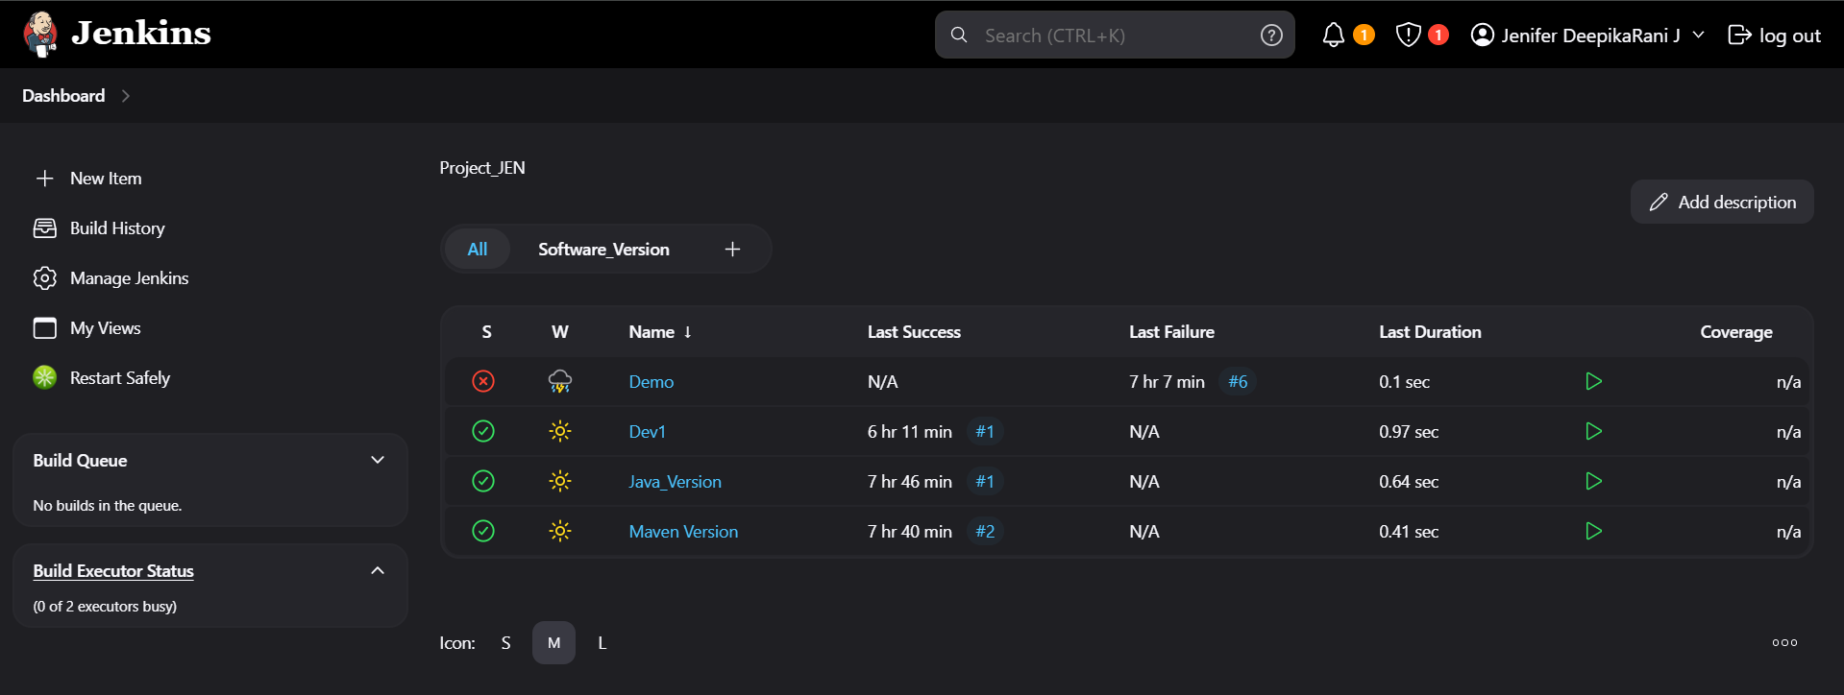

1. **We can customize the restart message over the text box.**

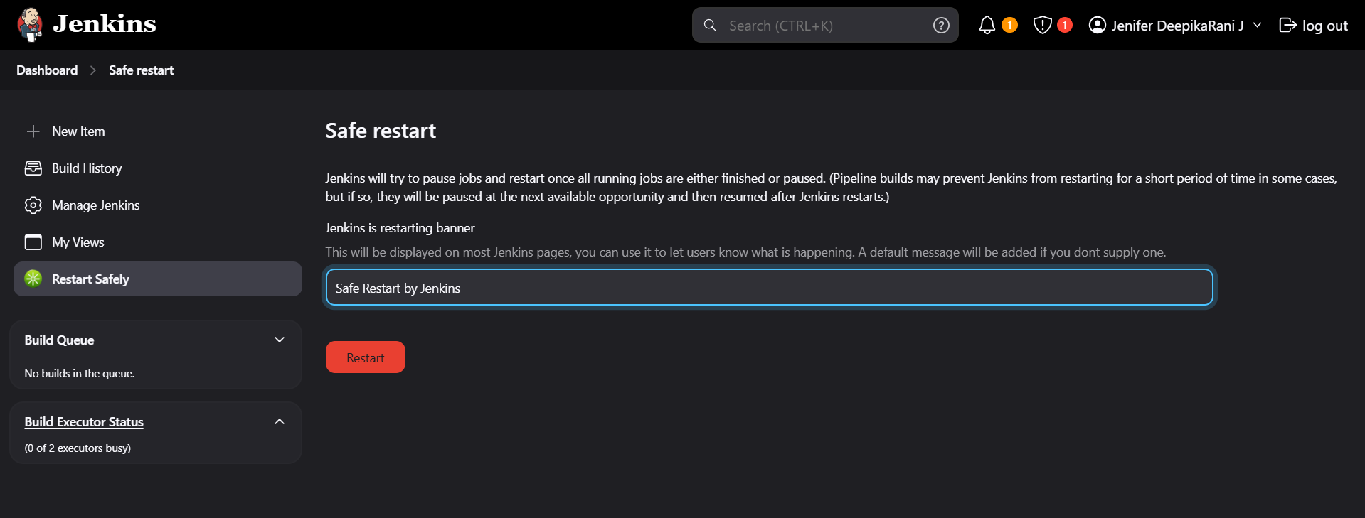

**Installed Plugins:**

The **Installed Plugins section** in the Jenkins Plugin Manager provides a list of all plugins that are currently installed in your Jenkins instance. This section is essential for managing, updating, and troubleshooting plugins.

**Advanced Settings:**

The Advanced Settings section is designed for administrators who need more control over how plugins are installed or updated, especially in enterprise environments or custom setups.

**External Plugin:**

* An **external plugin** refers to tools or integrations that are not part of Jenkins' Plugin Manager and need to be set up or integrated through third-party websites, APIs, or manual installation.
* Here, I have chose the “Job and Stage Monitoring Plugin” to install from third-party websites.
* The **Job and Stage Monitoring Plugin** is typically used in continuous integration/continuous deployment (CI/CD) tools like Jenkins to enhance visibility into the execution of jobs and stages. It provides a detailed view of how individual stages of a pipeline are progressing, including performance metrics, logs, and any errors or issues.

1. **Search “Job and Stage Monitoring” on the web browser, select the needed version in Releases section and download the file.**

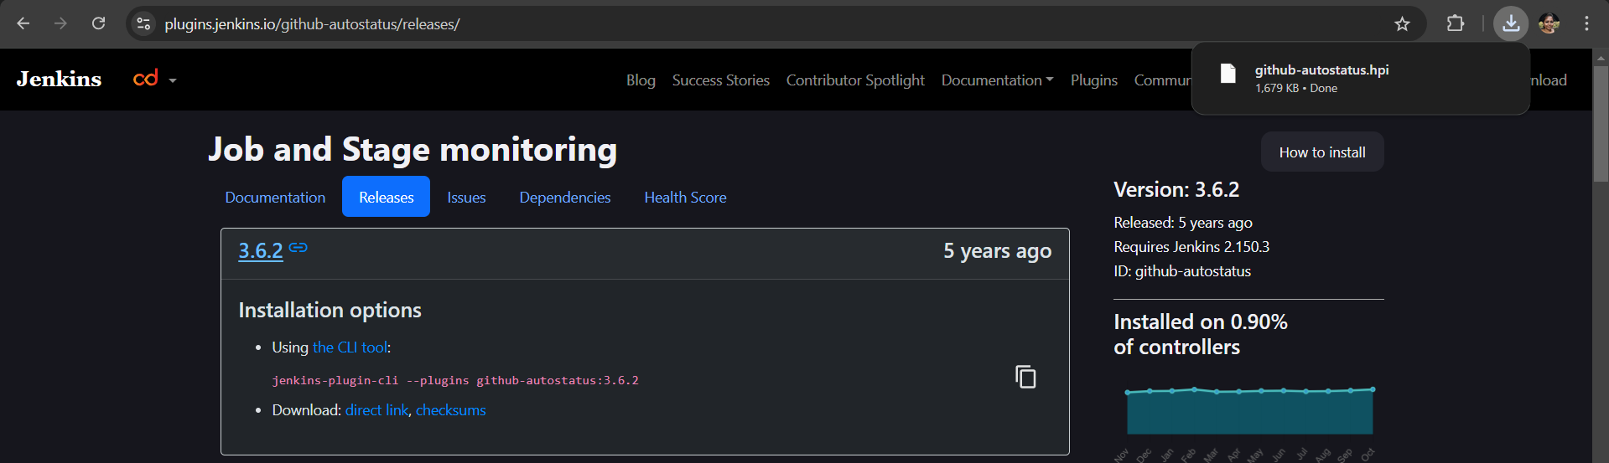

1. **The downloaded file automatically will located in the downloads folder in your laptop & it will be in the “.hpi” format.**

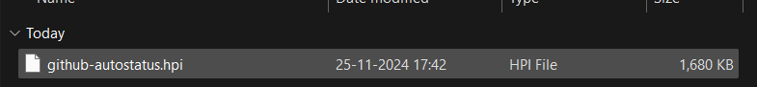

1. **Go to Dashboard->Manage Jenkins->Plugins->Advanced Settings->Click on Choose file->Select the file to be installed->Deploy**

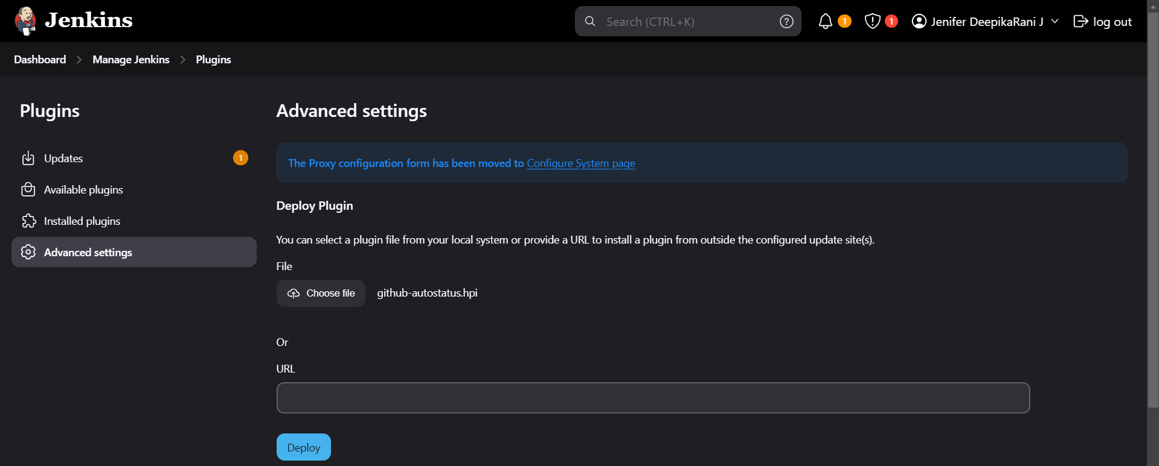

1. **The Download process will be started**

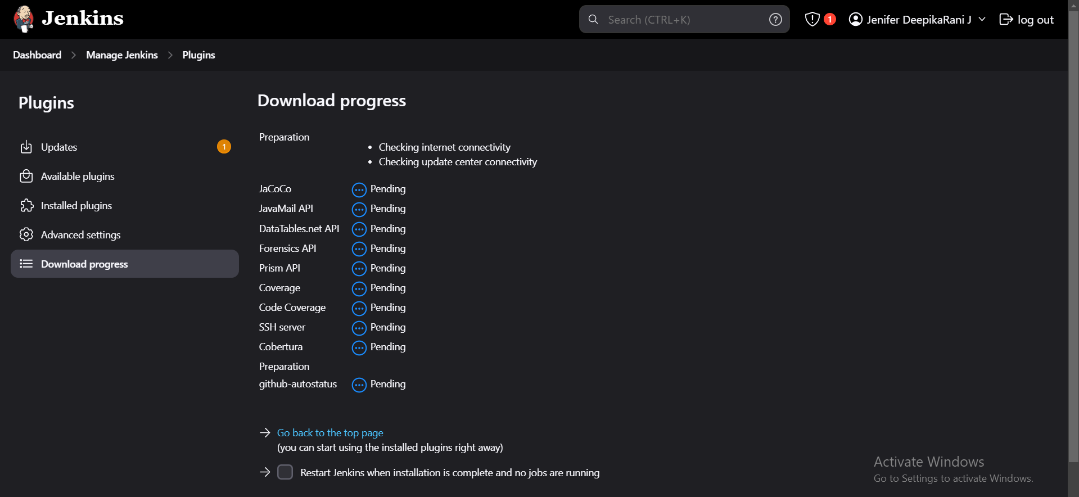

1. **Once it got downloaded then we have to restart the Jenkins.**

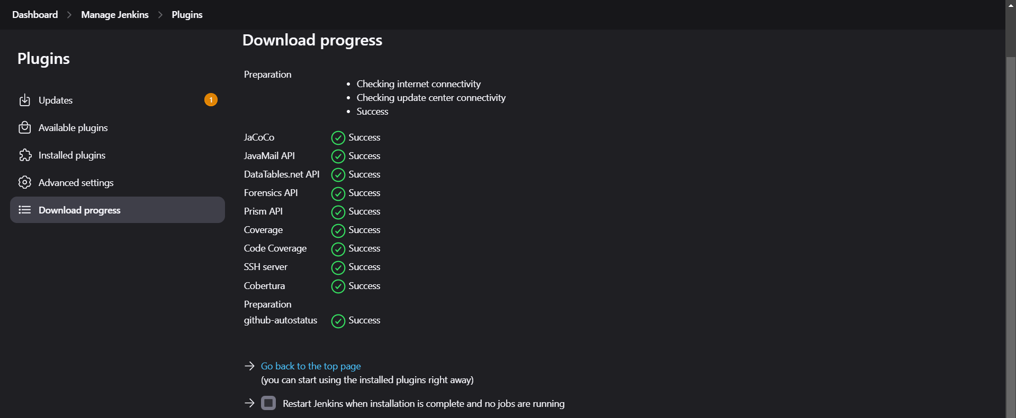

1. **Once the server got restarted, the plugin will be available in the Installed Plugin section and we have to confirm whether it is enabled or not.**

